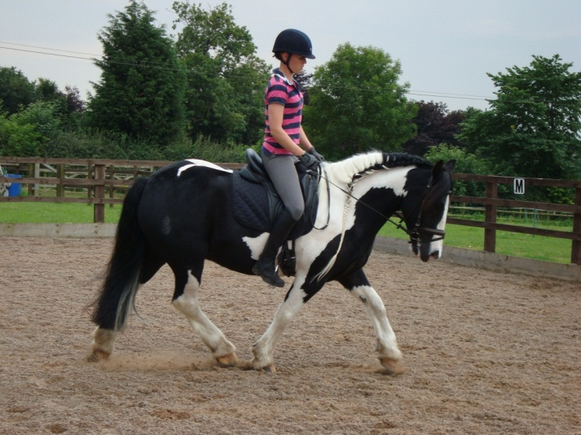For Sale
14hh piebald cob gelding, 5 years old.
Well schooled, willing and forward going but not strong. Never refuses a jump, jumping coloured and solid fences. He has been ridden by a disabled boy several times and was as good as gold.
He hacks alone and in company. Canters across open fields very sensibly. He is brilliant in the heaviest and noisiest traffic.
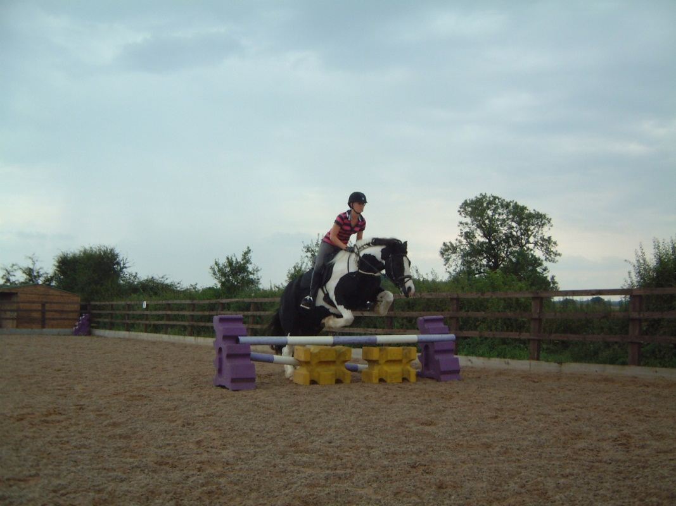Lovely markings, with a full black tail and traditional mane.
Very sane and sensible with lovely manners.
Good to clip, shoe, load and travel.
CHAPS passport, would make a lovely traditional show cob.
Up to date with vaccinations, teeth and worming.
Only for sale as owner has arthritis. £2,950
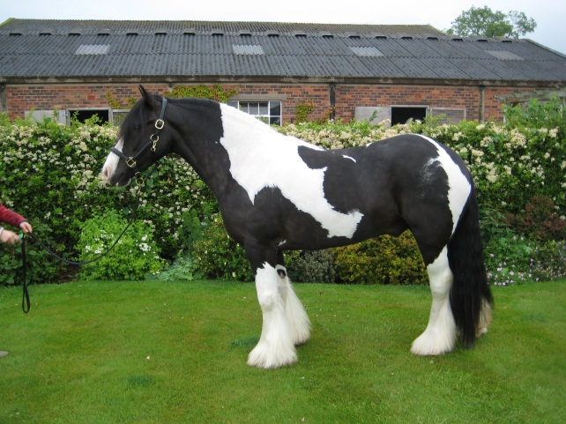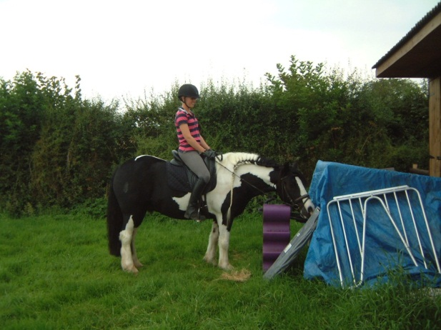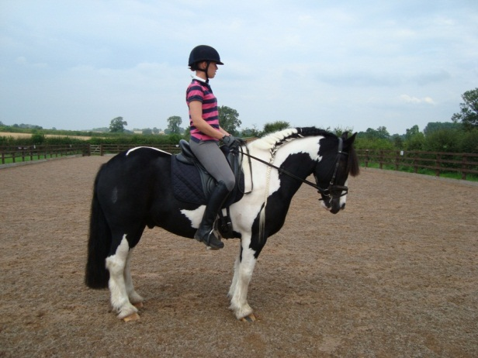Tel 01335 361015 / 07973 566841 (07730044796 if no answer)

