FOR SALE: CRISTAL
10year old, 14.2 Arab X Belgium Warmblood
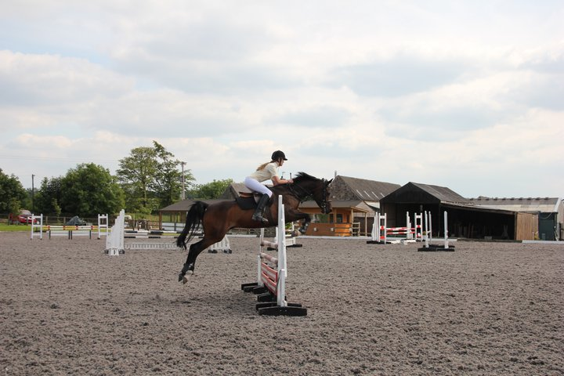
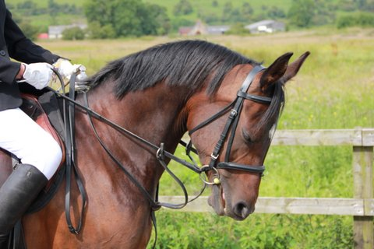
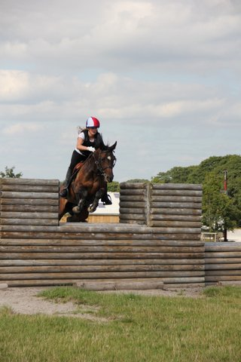
Cristal is a stunning BSJA registered Pony and loves X country too. She took my 12 year old daughter from unaffiliated to BSJA where she has excelled. She is very careful, loves to please and rarely has a pole. She currently jumps British novice and discovery with ease with double clears in both and lots of mileage left in both classes. She has great potential and has jumped many double clears at 1m+ classes and so there is scope for her to excel in the 1m + classes too. She loves to compete and when asked is very fast against the clock and so usually comes home with a red ribbon!
She was Area 18 BSJA discovery champion, and 2011and 2012 Beaver Hall 90cm and 1.0m champion. At Cricklands in past 2 years placed 2nd and 7th in 90cm class out of 72. Cristal is very bold over XC and won at novice to qualify for the SEIB XC finals but our busy schedule prevented us from competing!
This is a very reluctant sale for this much loved pony with great potential and only due to other sporting commitments and lack of time. This super mare needs a confident rider to continue to enjoy her current level of success but equally she could start a less experienced rider off on their introduction to 70/80 cm/BSJA show jumping or X country .She is a delightful mare to own is great to turn out or happy to be in the stable. She is great to travel, shoe, clip etc. (Based in Cheshire)
£6000
Tel: 07818 401 833 Email-jacqui.hazell@ntlworld.com

